Kansas Educational Data System

  - Data Validation Portal

Introduction
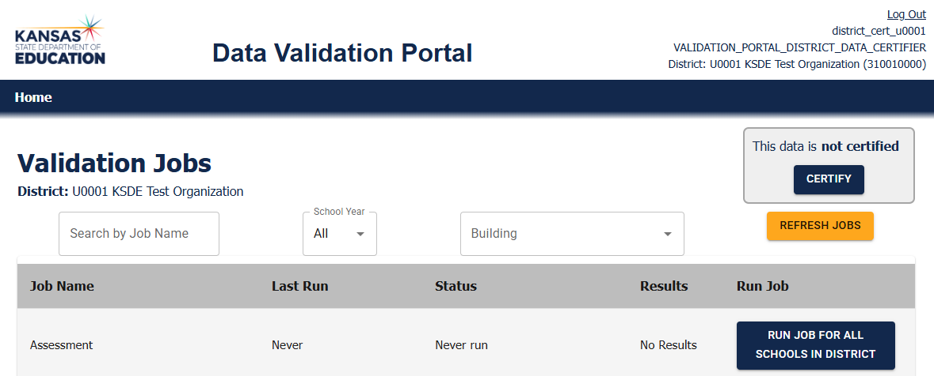
In the KIDS system, data is validated prior to uploading into the state system. In KEDS, data is uploaded to the KSDE data system while only having to meet the data format requirements. The content of the data will be required to be validated after uploaded and that is the purpose of the validation jobs. KSDE has transitioned the KIDS jobs into what appears in the Validation Jobs window. The name of this application is the Data Validation Portal or DVP.

Login
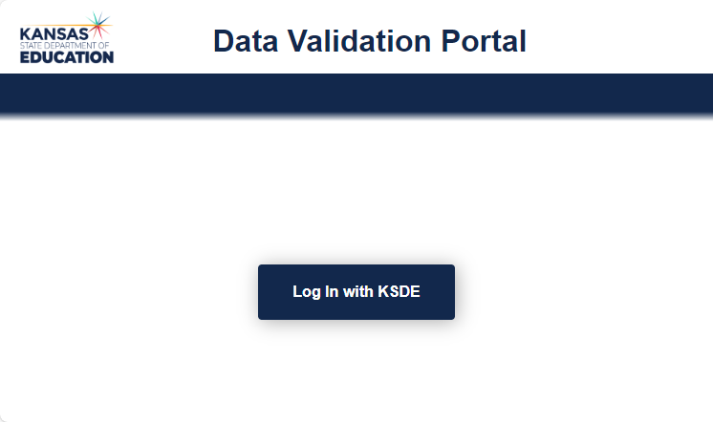
Access the KEDS Data Validation Portal by clicking the link below.
https://edfival.ksde.org/validationPortal/login
Click Log In with KSDE

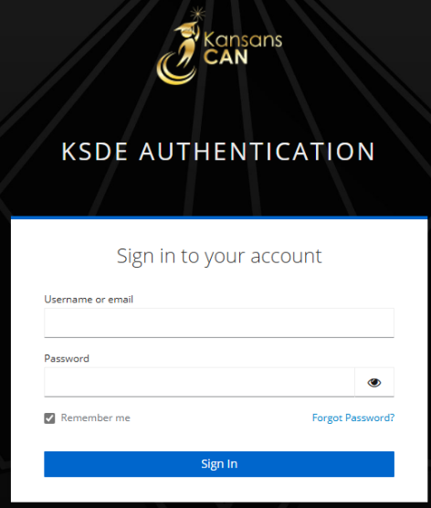
You will be taken to the new KSDE authentication system. Accounts to this system are currently being approved and configured manually.

- Enter your username and password, click Sign In and you will be sent to the Data Validation Portal home page.
- If you have forgotten your password, click “Forgot Password?” and an email with password reset instructions will be sent to you.

Navigation
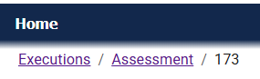
As you navigate through the Job Summary and Task List pages of the Data Validation Portal, a breadcrumb menu will appear which allows you to navigate back to the Home page or other pages.

Data Validation Portal Roles

The Data Validation Portal (DVP) has 6 roles for district and school level users. These roles are set when a user is created. Currently users can only have one role and district/school assigned. This information will be required when accounts are requested. The user role and district will be identified in the top right corner of the validation portal menu. A school will also be identified if a school level user.
- District Data Certifier: Able to view and run jobs and certify data for a specific district.
- District Job Run User: Able to view and run jobs for a specific district.
- District Job Read User: Able to view jobs for a specific district.
- School Data Certifier: Able to view and run jobs and certify data for a specific school.
- School Job Run User: Able to view and run jobs for the specific school.
- School Job Read User: Able to view jobs for their specific school.

Jobs Search
The Search, School Year, District and Building drop down allows you to select the rules and data set you are validating. These menus will be set based on your district or school role.
- The Search by Job Name allows you to search for a rules group by name.
- The School Year allows you to select the year of the data being validated. Current year will only be available until data from multiple years have been uploaded.
- A District Level User will have the district selected; they will be able to select a building.
- A School Level User will have the district and school selected and will not have the building drop down.
- The District and Building will display under the heading Validation Jobs
Click the REFRESH JOBS button
- The data validation rules will load based on the search criteria entered.
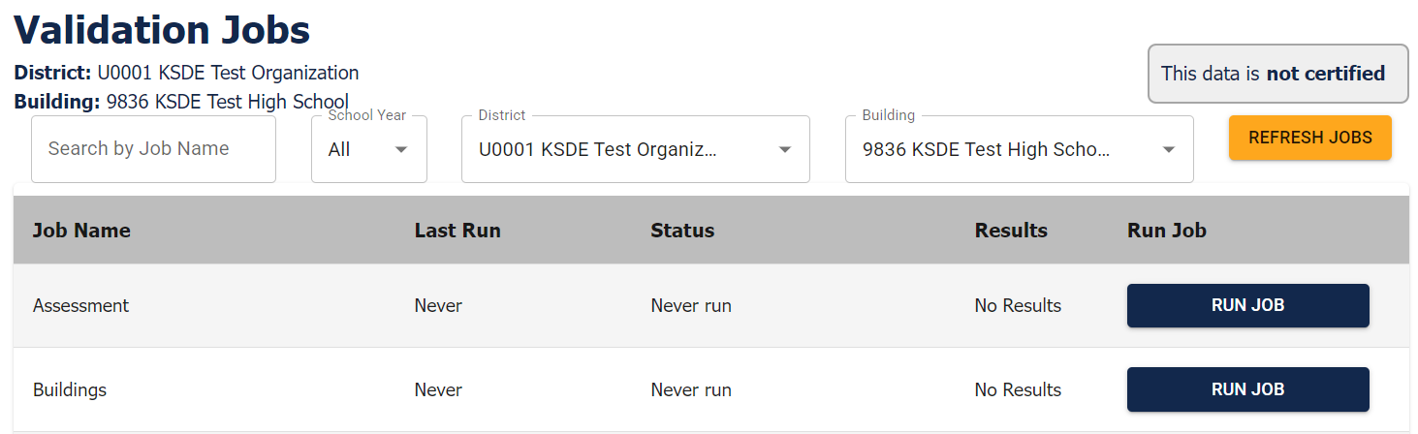
- The building will update under the heading Validation Jobs if switching from a district to building level search.
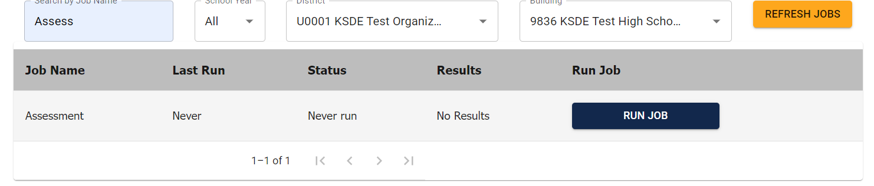
To search for a specific job, enter a portion or the full job name into the search box and click REFRESH JOBS. The job list will refresh with the list of jobs matching the name.
Each page will show 10 jobs, if there are more than 10, then at the bottom of the jobs list will show how many pages are available and the arrow buttons at the bottom of the page will be enabled to allow you to navigate to the next page.

Jobs Table
The validation jobs table shows the job name, last run date and time, status, results and the RUN JOB button. Click the RUN JOB button to run that job. After a few seconds, the result of the job will be returned. You do not need to click refresh in the browser or the REFRESH JOBS button for the results to load.
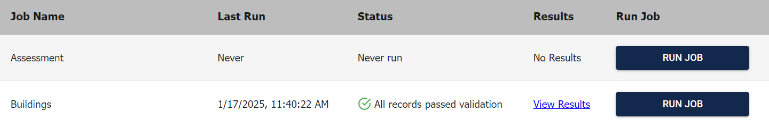
After jobs have run, the status column may show passed or errors. The results will now provide a View Results link. Click this link and you will go to the Job Summary Page.

Job Summary Page
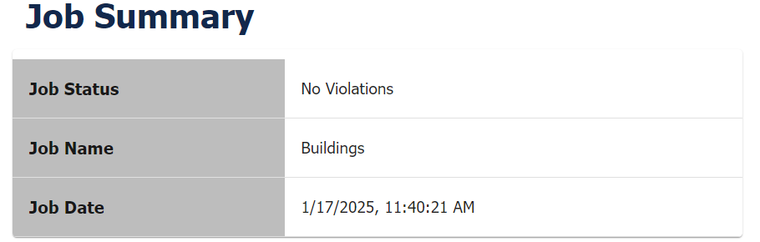
The Job Summary Page provides details of the job as well as a listing of the rules.
The listing will show the KSDE rule identifier number, the result, the rule description, the number of records found and the link to view the results will appear if records are available.
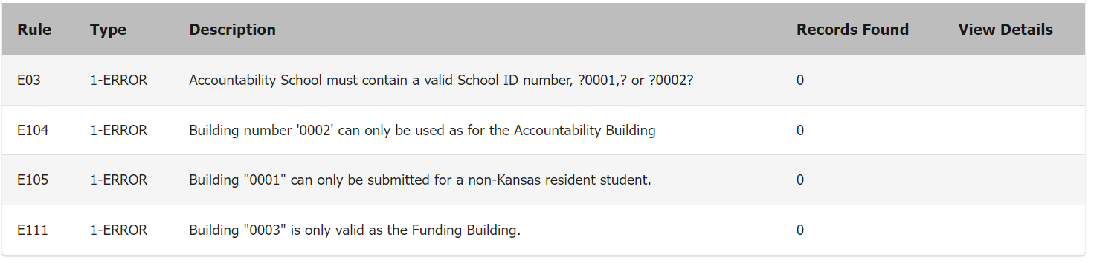

Click on the View Details link to view the list of each record found. Currently only the first 200 records are shown.


At the bottom of the Job Summary page, the EXPORT ALL DETAILS TO CSV button is available if records are available.

Task List Page
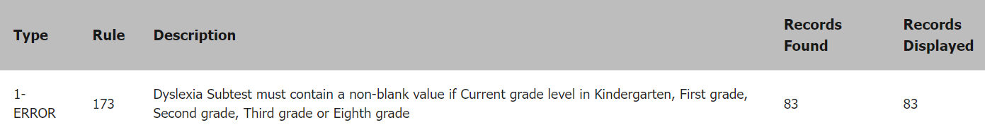
The task list page will show the records that need to be reviewed for validation.

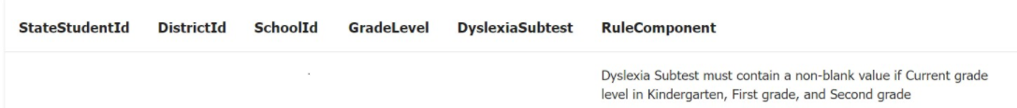
Under task summary will be a listing of the individual records with errors. Each chart menu will list the State Student Id, District Id, School Id and rule related components.


At the bottom on the Task List page, the EXPORT TO CSV button allows you to export the first 200 records.

EDFI Credential Manager
The EDFI Credential Manager page will allow authorized users to retrieve their associated district/school key and secret.
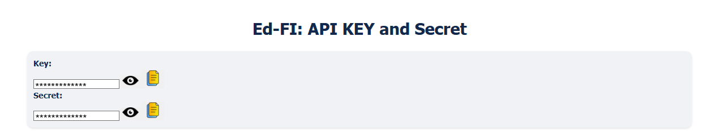
Only users assigned with the role ‘Key Master’ can access the EDFI Credential Manager page.

Keys and Secrets are automatically hidden by asterisk symbols for users accessing the page. Users can view/copy the listed key and secret by selecting the eye and paper icons.

Once a districts key and secret has been used for authentication to upload data, the key and secret will be hidden on the EDFI Credential Manager page. If districts need to access their key and secret, contact KSDE and we will generate a new key combination.

Key and Secrets are updated annually; previous school year key and secrets will not be allowed for authentication to upload data.

Key and Secret combinations should be kept secure. It is KSDE's guidance to not copy them to any other location.

For more information, contact:  KEDS Project Team  Information Technology Department  (785) 296-3300  keds@ksde.gov |  | Kansas State Department of Education  900 S.W. Jackson Street, Suite 102  Topeka, Kansas 66612-1212  (785) 296-3201  www.ksde.gov
The Kansas State Department of Education does not discriminate on the basis of race, color, religion, national origin, sex, disability or age in its programs and activities and provides equal access to the Boy Scouts and other designated youth groups. The following person has been designated to handle inquiries regarding the nondiscrimination policies: KSDE General Counsel, Office of General Counsel, KSDE, Landon State Office Building, 900 S.W. Jackson, Suite 102, Topeka, KS 66612, (785) 296-3201.
January 2025

